se18

**Create CLASSIC BADI**

1) sfgfdfgd

dont click create

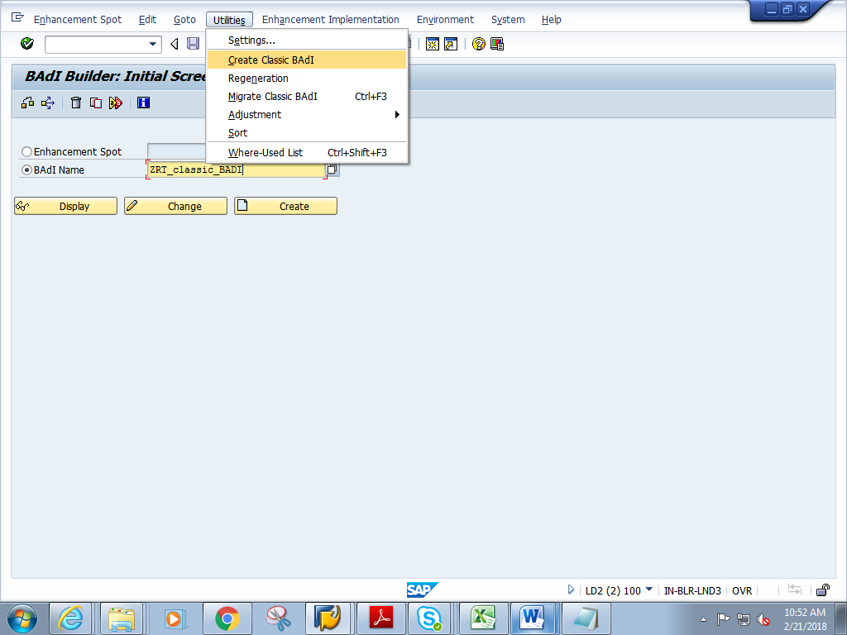

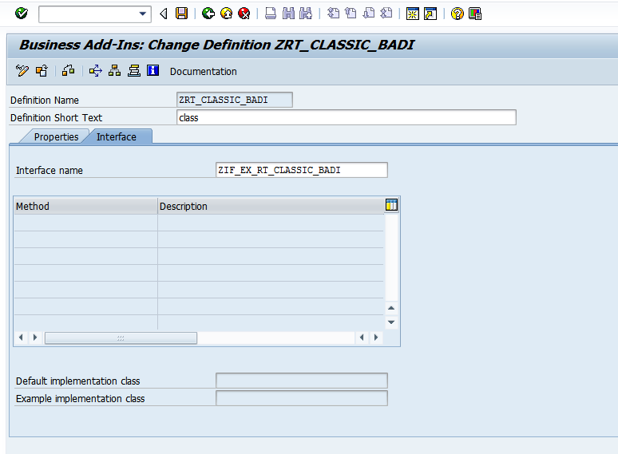

double click on interface name

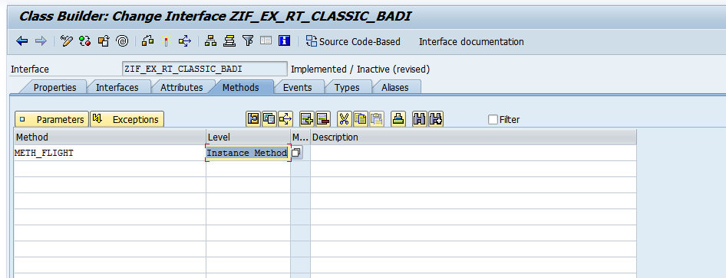

create table type

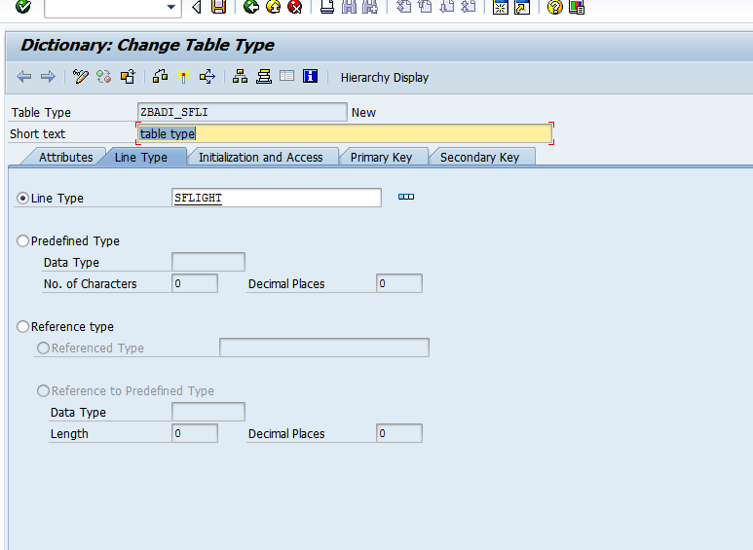

give parameters

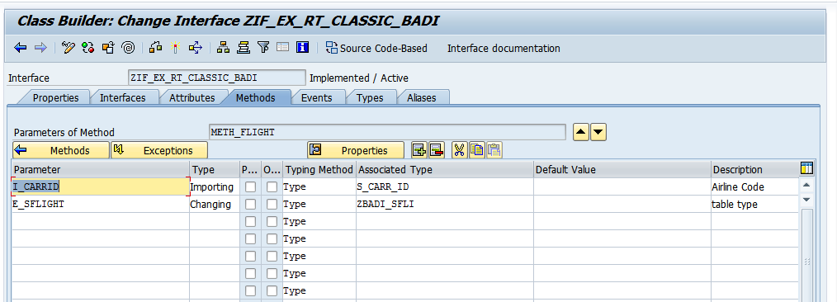

save and activate

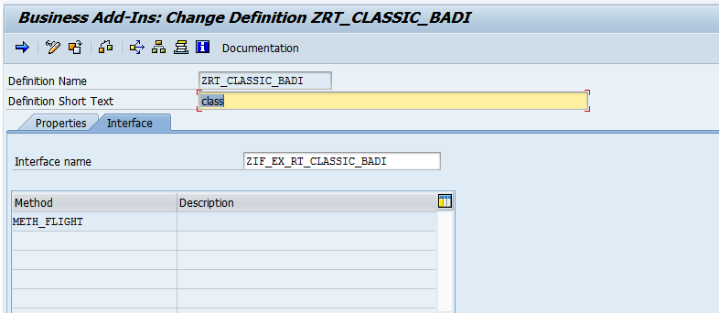

badi implementation

se19

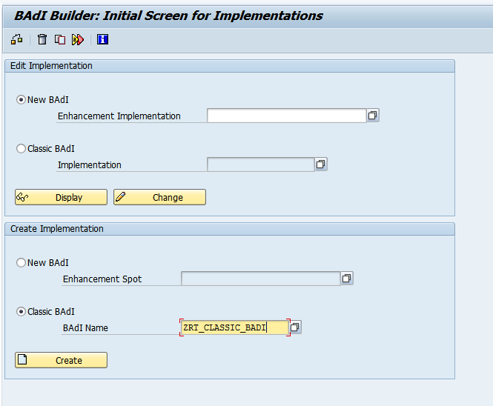

click on create

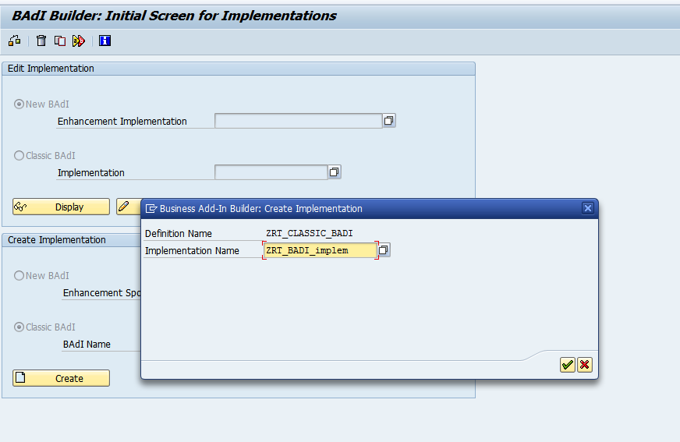

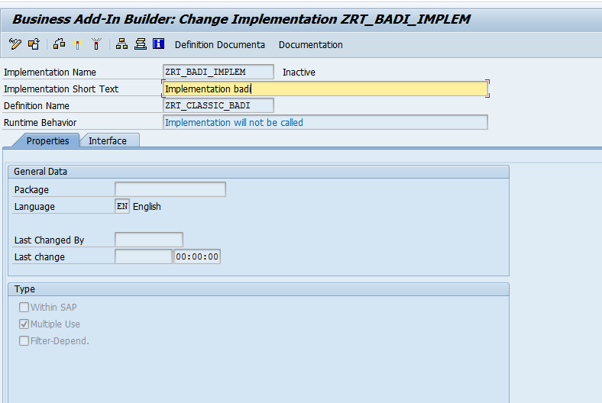

in interface tab, Double click on class and create it

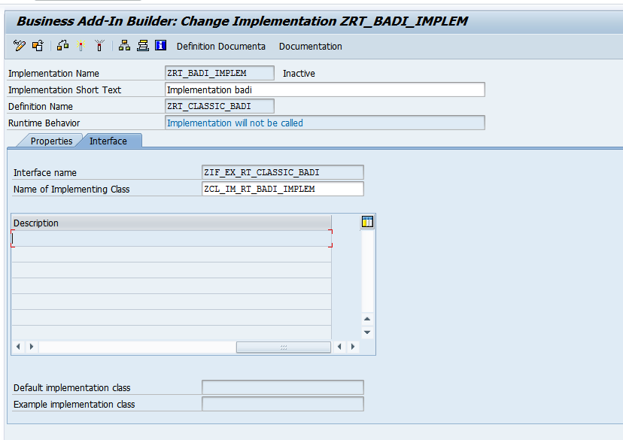

the classs opens up.In the method

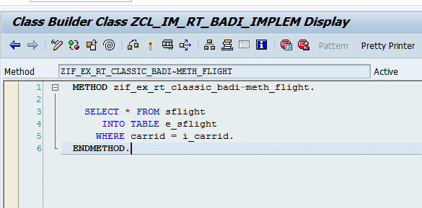

Save and activate the class .Go back

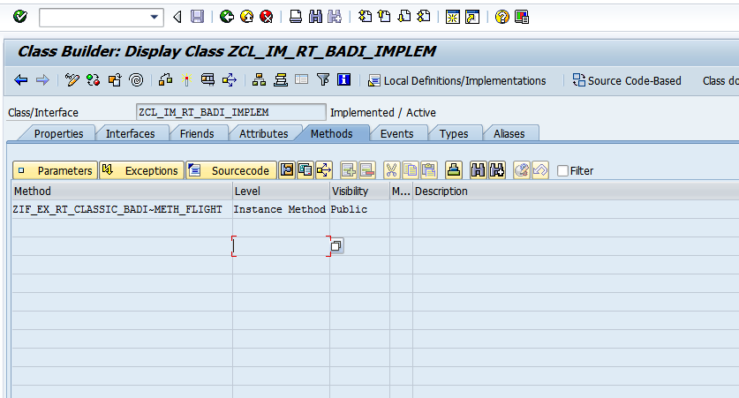

.Save and activate the BADI Implementation

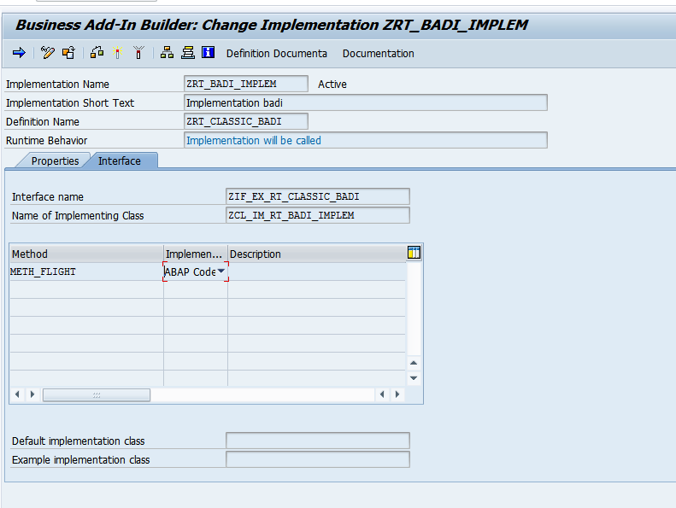

create report

and add below logic

*&---------------------------------------------------------------------*  
*& Report ZCLASSIC_BADI_PRG  
*&---------------------------------------------------------------------*  
*&  
*&---------------------------------------------------------------------*  
REPORT ZRT_CLASSIC_BADI_PRG.  
  
DATA:  IT_TAB TYPE  ZBADI_SFLI,  
       WA_TAB LIKE LINE OF IT_TAB.  
  
  
PARAMETERS P_carrid type S_CARR_ID.  
  
  
START-OF-SELECTION.  
  
DATA OBJ1 TYPE REF TO ZIF_EX_RT_CLASSIC_BADI."Interface from se19  
  
  
CALL METHOD cl_exithandler=>get_instance  
  EXPORTING  
    exit_name                     = 'ZRT_CLASSIC_BADI'"Name of badi while creating BADI in se19  
*    null_instance_accepted        = SEEX_FALSE  
*  IMPORTING  
*    act_imp_existing              =  
  CHANGING  
    instance                      = OBJ1  
*  EXCEPTIONS  
*    no_reference                  = 1  
*    no_interface_reference        = 2  
*    no_exit_interface             = 3  
*    class_not_implement_interface = 4  
*    single_exit_multiply_active   = 5  
*    cast_error                    = 6  
*    exit_not_existing             = 7  
*    data_incons_in_exit_managem   = 8  
*    others                        = 9  
        .  
IF sy-subrc <> 0.  
* Implement suitable error handling here  
ENDIF.  
  
CALL METHOD obj1->meth_flight  
  EXPORTING  
    i_carrid = P_carrid  
  CHANGING  
    e_sflight  = IT_TAB  
    .  
  
  
LOOP AT IT_TAB INTO WA_TAB.  
  WRITE : / WA_TAB-carrid,  
            WA_TAB-connid.  
  
  
  
  ENDLOOP.